**Jason Becker, Omomhene Eimunjeze, Tylar Giraud**

**Exercise #2**

Exercise 1 Code below change exercise from ST to IL and vice versa

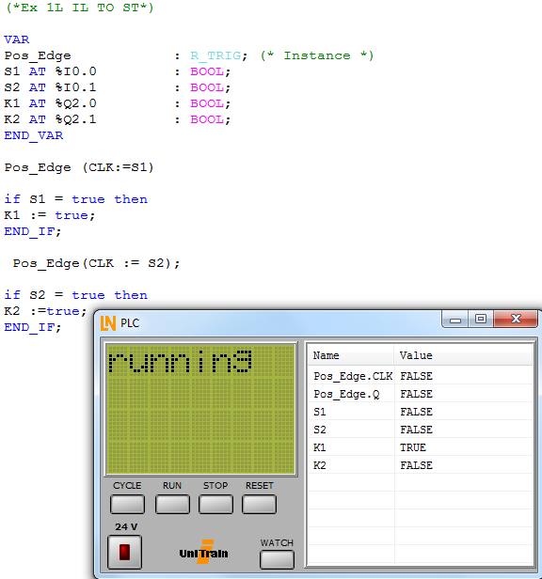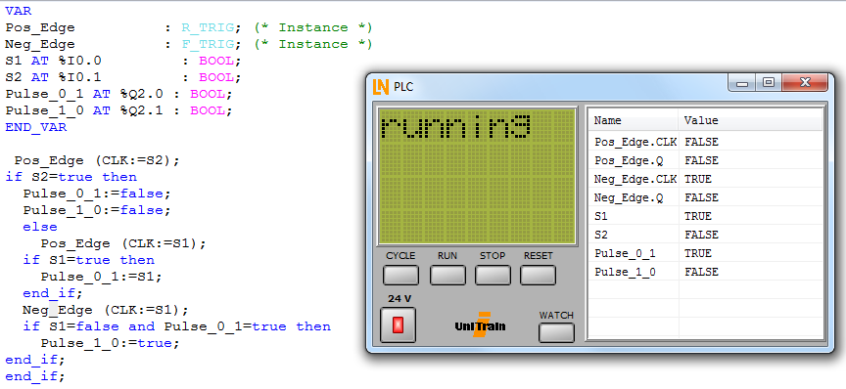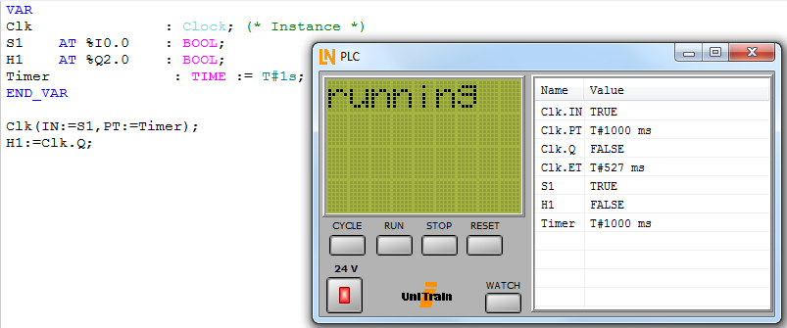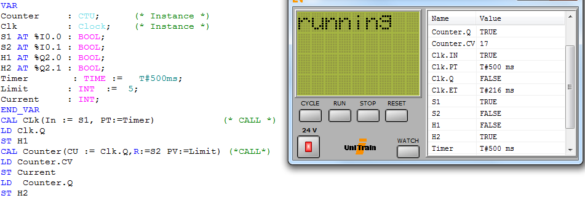

EXERCISE 2

Edge triggering means that the signal becomes active depending on clock signal edge. Positive-edge triggering is when the clock is rising to positive edge then the signal is active. When the negative-edge triggering, the signal is active when the clock is on the falling edge.

EXERCISE 3

For switch-on delay timer is a switch that is closes the circuit when the timer is energized(powered on) for a certain amount of seconds. When the timer is de-energized, the switch-on delay timer is immediately open thus opening the circuit. For a switch-off delay timer, when the timer is energized(power on) the contact of the switch-off time delay is instantly energized and the circuit is closed. Then after the circuit is closed, the switch-off delay timer remains on for a certain amount of time after the timer is de-energized.

EXERCISE 4

If the count-down counter goes below zero, the output bit turns on.

EXERCISE 5

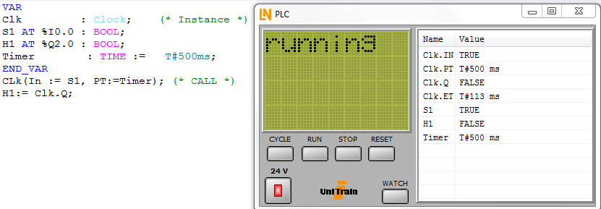

Program above written in ST, Clock dictates the time H1 or led1 will flash, which is every 500 milliseconds in our case.

EXERCISE 6

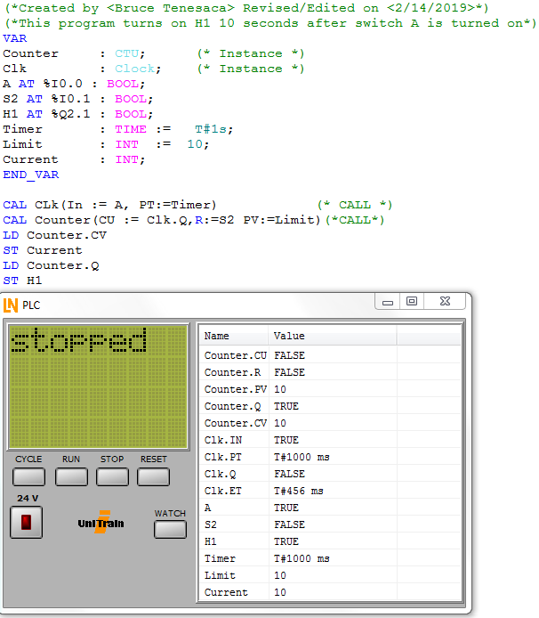

Program above written in IL, the output H1 will turn on after 10 seconds the switch is flipped.

EXERCISE 7

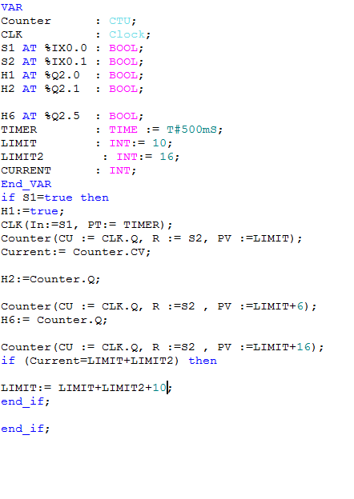

Program above written in ST, this program uses a clock, counter and a limit set to set the led to shine in intervals then shut off after ten seconds.

EXERCISE 8

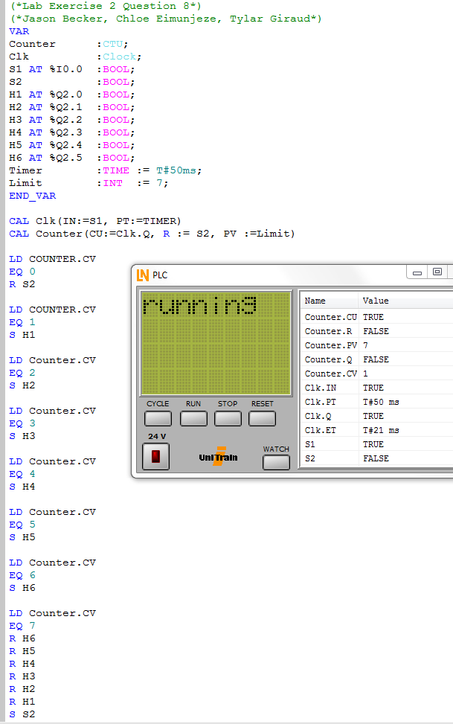

Program above is in IL, same does the same job as program 7.

EXERCISE 9

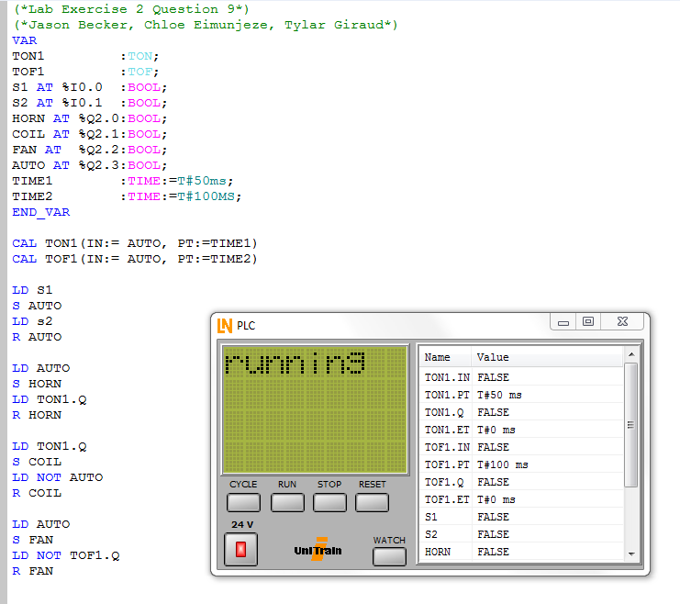

Program 9 above written in IL. The program is to control a heating oven. Once set in auto, the horn and coil should start, and have a timer of 50 ms and after 100 ms the system should turn off but the fan should remain for the remaining time.

EXERCISE 10

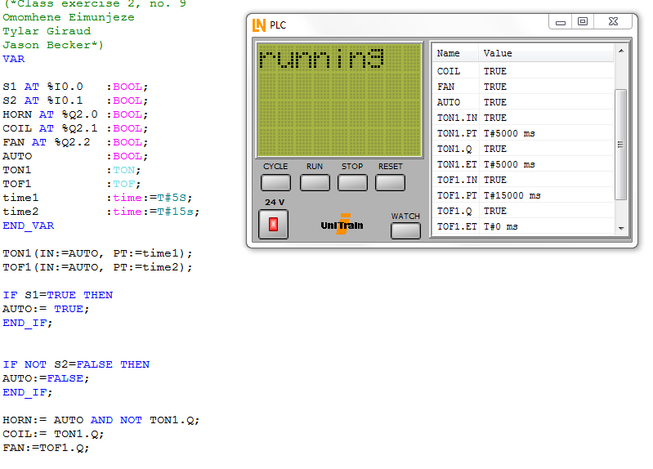

Program 10 is the same as program 9.